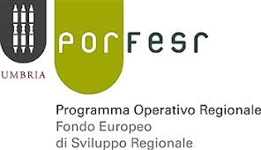
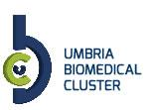
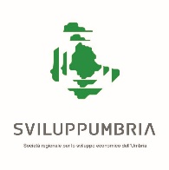
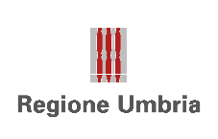
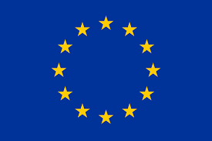
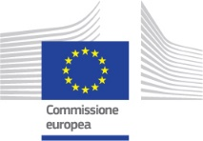

10 Dicembre 2018, ore 11:00

Conference Call

Personalised Medicine

Boosting Health Research, Opportunities From European Commission

Sede dell’evento: RPA Ricerche e Progetti S.p.a.

Fraz. Fontana - Strada del Colle n. 1/A - Perugia

- Introduction
Mariano Gattafoni, President of Biomedical Cluster in Umbria Region.
He’ll present briefly the activities of SMEs active in the Sector of Personalised Medicine.

- Indridi Benediktsson , Jean-Luc Sanne, Michael Proteriotis from the European Commission, DG Research and Innovation, Directorate Health.
They will respond to your questions about general opportunities in the sector of Personalised Medicine.

The official language of the Conference Call is English.

